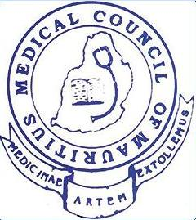

MEDICAL COUNCIL OF MAURITIUS
is pleased to invite members of the Medical Profession
to a ½ day CPD event scheduled for Saturday 28 October 2023
1 CPD credit point per lecture will be allocated to each participant

Venue: Auditorium of the Medical Council of Mauritius at Floreal
No of seats available: 200
Kindly reserve your seat by Monday 23 October 2023 at 12.00 hrs. by calling on the following number 6988340.

Programme of the Event

Time | Title | Speaker
Moderator: Dr. A Foondun
13.00 – 14.00 | Liposculpture and fat stem cell grafting-shaping perfection | Dr Rakesh Newaj  Qualifications:  MBBS  Fellow of the College of Dermatologists of South Africa
14.00-14.30 | Break
14.30-15.30 | Skin reactions from medication | Dr Rakesh Newaj  Qualifications:  MBBS  Fellow of the College of Dermatologists of South Africa

Registrar
Medical Council of Mauritius

12 September 2023 10, 2023

